Blood Spatter Analysis using through CNN

Abstract
Some scenes of violent crime contain blood stains. Blood spatter stains occur when blood falls passively due to force being applied to a body. There is a well-established though extremely tedious technique by which a specially trained forensic technician can analyse the individual blood spots. This procedure estimates the body's 2D location on the floorplan when the body was impacted. Our image analysis algorithm contributes an automatic and accessible alternative that could be exploited at crime scenes, assuming the stains are known to be the result of spatter. This paper presents our approach and the results of comparative experiments we used to confirm the accuracy of the algorithm.
Keywords: Blood Spatter, Analysis.

CHAPTER 1
INTRODUCTION
1.1 Aim of study
The aim of blood spatter analysis, also known as bloodstain pattern analysis, is to interpret the patterns and characteristics of bloodstains at a crime scene to gain insights into the events that occurred during the incident. It is a forensic technique that helps investigators reconstruct the sequence of events, determine the type of weapon used, establish the position and movement of the victim and perpetrator, and provide additional information that can aid in crime scene reconstruction.
Blood spatter analysis relies on the understanding of the physics and dynamics of bloodstain formation. When blood is subjected to force or impact, such as from a gunshot, stabbing, beating, or other violent actions, it can create unique patterns. By examining the size, shape, distribution, and directionality of bloodstains, along with other factors like the surface characteristics and angles of impact, experts can make inferences about the actions that took place.
1.2 Objective
The specific objectives of blood spatter analysis include:
- Determining the point(s) of origin: By analyzing the patterns of blood spatter, investigators can identify the area or point from which the blood was projected. This can help establish the location of the victim, the attacker, or the impact source.
- Estimating the angle of impact: The angle at which blood strikes a surface can provide information about the relative positions of the victim and the attacker. By analyzing the shape and elongation of bloodstains, experts can estimate the angle at which the blood impacted the surface.
- Classifying the type of impact: Different types of impact, such as high-velocity spatter from gunshot wounds or cast-off patterns from a swinging weapon, can produce distinct bloodstain patterns. By examining the characteristics of the stains, analysts can classify the type of impact and potentially infer the type of weapon or force used.
- Reconstructing the sequence of events: Blood spatter analysis, when combined with other evidence and witness statements, can help reconstruct the sequence of events during a crime. By considering the patterns, their locations, and the timing of bloodshed, investigators can piece together a narrative of what happened.
- Corroborating or challenging witness accounts: Blood spatter analysis can provide objective evidence that either supports or contradicts witness statements or suspect claims. It can help corroborate or challenge the accounts of those involved in the incident
  - Scope
The scope of blood spatter analysis, also known as bloodstain pattern analysis, encompasses a range of applications within the field of forensic science.
Blood spatter analysis plays a vital role in crime scene investigation. Forensic experts examine bloodstain patterns to determine the type of force, the sequence of events, the position and movement of individuals, and other relevant information to reconstruct the crime scene.
The scope of blood spatter analysis extends to various aspects of forensic science and crime scene investigation, offering valuable insights into the dynamics and events surrounding incidents involving bloodshed. Its applications can contribute to the accurate interpretation of evidence, aid in the pursuit of justice, and provide scientific support to investigative processes and legal proceedings.
1.4 Introduction
Blood spatter analysis, also known as bloodstain pattern analysis, offers several advantages in forensic investigations.
Blood spatter analysis provides valuable insights into the sequence of events and dynamics of a crime scene. By examining bloodstain patterns, experts can reconstruct the actions that took place, the movements of individuals involved, and the relative positions of the victim and perpetrator. This information can help investigators build a comprehensive picture of the crime and enhance their understanding of what occurred.
Blood spatter analysis provides objective scientific evidence that can support or challenge witness statements, suspect claims, or other forms of subjective testimony. The patterns and characteristics of bloodstains are based on physical principles and can be analyzed objectively, providing an unbiased perspective in the investigation process.
Blood spatter analysis can corroborate or contradict witness accounts, victim statements, or suspect statements. By comparing the observed bloodstain patterns with the reported events, investigators can determine the consistency and reliability of the testimonies, potentially strengthening the overall case.
Blood spatter analysis can provide insights into the type of weapon used in an incident. The characteristics of bloodstain patterns, such as the size, shape, and distribution, can indicate the force and impact associated with different types of weapons. This information can assist in identifying the weapon and corroborating or refuting claims made by the involved parties.
Blood spatter analysis can help investigators establish the boundaries of the crime scene. By analyzing the dispersion of bloodstains and the directionality of spatter, experts can determine the areas affected by the incident. This aids in determining the extent of the crime scene, identifying potential points of entry or exit, and focusing investigative efforts.
Blood spatter analysis can provide insights into the manner of death, such as gunshot wounds, stabbings, or blunt force trauma. By examining the patterns and characteristics of bloodstains in conjunction with other forensic evidence, investigators can determine the cause and manner of death, supporting the determination of homicide, suicide, or accident.
Blood spatter analysts can provide expert testimony in legal proceedings. Their specialized knowledge and experience can assist the court in understanding the significance of bloodstain patterns, the interpretation of evidence, and the relevance to the case. Their testimony can strengthen the prosecution or defense's arguments and provide scientific support to the decision-making process.
Blood spatter analysis can guide further investigation and help prioritize leads. By analyzing the bloodstain patterns, investigators can identify areas that require additional scrutiny, potential sources of additional evidence, or new lines of inquiry. This focused direction can optimize investigative efforts and contribute to a more efficient investigation

Blood splatter analysis, also known as bloodstain pattern analysis, has various applications in forensic science and crime scene investigation.
Blood spatter analysis helps reconstruct the events that occurred at a crime scene. By examining bloodstain patterns, experts can determine the sequence of events, the positions of individuals involved, the type of force applied, and other crucial details. This aids in reconstructing the crime and providing insights into what happened.
Blood splatter analysis plays a crucial role in homicide investigations. It can help determine the manner of death, such as gunshot wounds, stabbings, or blunt force trauma. By analyzing bloodstain patterns, experts can provide evidence to support or challenge witness statements, identify the weapon used, establish the number of blows or shots, and contribute to the overall understanding of the crime.
Blood spatter analysis is applicable in cases involving assault and battery. By examining bloodstain patterns, investigators can determine the dynamics of the altercation, the type and direction of force applied, and the relative positions of the individuals involved. This analysis can assist in assessing the level of violence, self-defense claims, and the severity of injuries.
Blood spatter analysis can be used in accident reconstruction, particularly in cases involving traumatic injuries or fatalities. By examining bloodstain patterns and their distribution, experts can provide insights into the sequence of events, the movements of individuals involved, and the dynamics of the accident. This analysis can help determine liability, assess contributing factors, and provide a scientific basis for accident investigation.
Blood spatter analysis can contribute to sexual assault investigations. It can help determine the position and movements of the victim and perpetrator during the incident. By analyzing bloodstain patterns and their characteristics, experts can provide insights into the events leading up to and during the assault, aiding in the investigation and legal proceedings.
Blood splatter analysis is valuable in firearm-related investigations. By examining bloodstains in conjunction with gunshot residue and bullet trajectories, experts can reconstruct the shooting incident. This analysis can help determine the position of the shooter, the range at which the shots were fired, the number of shots fired, and other details relevant to the investigation.
Blood spatter analysts often provide expert testimony in court proceedings. They explain the significance of bloodstain patterns, their interpretation, and their relevance to the case. Expert testimony helps the court and the jury understand the scientific aspects of blood spatter analysis and its implications for the investigation.
Blood spatter analysis, also known as bloodstain pattern analysis, is a forensic technique used to interpret and analyze the patterns and characteristics of bloodstains at a crime scene. It is based on the principle that when blood is subjected to force or impact, it creates distinct patterns that can provide valuable information about the events that occurred during a violent incident.
Blood spatter analysts, trained in the field of forensic science, examine various aspects of bloodstains such as their size, shape, distribution, and directionality. By analyzing these patterns, experts can reconstruct the sequence of events, determine the type of force applied, identify the position and movement of individuals, and gather evidence to support or challenge witness statements and suspect claims.
The analysis of blood spatter involves applying scientific principles and utilizing knowledge of physics, biology, and mathematics. Analysts consider factors such as the angle of impact, velocity of blood droplets, and the interaction of blood with surfaces. They also take into account the characteristics of the blood, the type of surface on which it is found, and any potential environmental factors that may have influenced the blood spatter.
Blood spatter analysis is particularly relevant in investigations involving violent crimes such as homicides, assaults, and accidents with significant bloodshed. It aids in crime scene reconstruction, determining the manner of death, identifying the type of weapon used, corroborating or challenging witness accounts, and providing objective scientific evidence in legal proceedings.
By examining the patterns left behind by bloodstains, blood spatter analysis helps forensic investigators piece together the puzzle of a crime scene, uncover hidden details, and contribute to the pursuit of justice. It is a specialized field within forensic science that requires expertise, precision, and attention to detail to draw accurate conclusions and provide valuable insights into the dynamics of violent incidents.
Reconstruction of the events from autopsy and scene findings is one essential objective in death investigations. The presence of bloodstains at the crime scene can be of major importance for the investigation and reconstruction. In addition to haemogenetic individualisation, the morphology and distribution of bloodstain patterns can provide vital information on the character, number and chain of events, which have caused the bloody scene. Before such interpretation of bloodstain patterns can be carried out reliably, the expert must have built up knowledge of and experience in the types of stains and distributions, which may be caused by various forms of injuries and mechanisms.
In addition to systematic studies case reports may significantly contribute to the validation of bloodstain pattern analyses, especially if the reconstruction is confirmed by witnesses or perpetrators. This is why a series of illustrative case examples involving various bloodstain distribution patterns is presented where the mechanism of production was verified by a confession of the offender. The cases originated from the Institute of Legal Medicine, University of Mu¨nster, Germany, where crime scenes are regularly investigated.
Arterial blood spatters originating from a corpse? A 23-year-old man was found dead near his car in some woods. The missing head had been severed at the level of the 6th cervical vertebra, which showed 3 deep notches. Signs of severe anaemia were obvious in the trunk of the body, but only a few bloodstains were found inside the boot of the car. A suspect, who was soon arrested, led the police to the site in the wood where he had buried the head, which showed 2 intracranial gunshot wounds from a 5.6- mm rimfire rifle. The suspect claimed that he had performed the decapitation with an axe in an aviary, after the victim was dead.
The crime scene investigation in the aviary (3 m 3 m) (Fig. 1a) took place 5 days after the killing. On the left side of the door, the lower part of the wire netting showed abundant tiny blood deposits and a large diagonal smear stain directed downwards. Below these stains and covered by some sand, the soil was soaked with blood over an area measuring 80 cm 25 cm and up to 20 cm deep. A wooden beam at the bottom of the wire netting also showed extensive red–brown discolouration from blood. On the right side of this blood stain, abundant splash stains in the form of tiny circular and elongated bloodstains were still visible on the beam (Fig. 1b).

The stains extended over a distance of 70 cm. On the left side of the pool of blood, large droplet stains were found beneath the sand, and a small passage to a stable showed additional droplet stains and large smear stains on the floor and walls. The perpetrator had fired the gunshots to the head while the victim was sitting in the sand and the falling head had caused the smear stain on the wire netting. Decapitation with the axe produced most of the pool of blood as well as abundant arterial spray stains, which were still present on the right side of the beam. This and the large amount of blood present required active heart. function. Therefore, the decapitation must have been performed shortly after the gunshots when the victim’s heart was still beating. The corpse had subsequently been dragged through the passage, which had caused the droplet and smear stains. In court, the perpetrator verified this reconstruction.
Dynamic or static situation? A 52-year-old man was beaten to death with a metal pipe in his living room. Autopsy verified five distinct fracture systems of the skull, each originating from a blow. The cause of death was cerebral injury. A suspect who admitted to have killed the man in a fight was arrested. An important factor in the reconstruction was the exact location where the fatal blows had been delivered and the dynamics of the chain of events. The corpse was lying in front of a sofa in a pool of blood. A panel close to the head of the corpse showed a tight pattern of impact splash stains (Fig. 2).
This and abundant radial blood spatter stains present on the sofa and walls indicated that the victim had not moved. Contrary to all other objects in the vicinity, an armchair was completely spared of bloodstains: it had been shielded by the body of the perpetrator. This means that all or most blows had been delivered while the assailant and the victim remained in the same position. This is incompatible with a dynamic situation such as a fight. In court, the defendant admitted that he had taken his acquaintance by surprise. The man collapsed in front of the sofa and the defendant had delivered additional blows to the head while standing in front of the chair.
The sequence of events can make the difference A young mother and her two children aged 6 months and 2 years were found dead, each lying in their bed at home. A bloody axe was present at the scene and the three victims had suffered fatal brain injuries from multiple blows with this axe. The husband claimed that his wife had first killed the two children and that he subsequently had killed her after he had seen what she had done. The crucial question was the sequence of events. The three victims were lying in their beds in separate rooms with a large number of bloodstains present on the beds, the victims, walls and at the ceilings. The wife showed numerous tiny splash stains, among others, on the back of the left hand (Fig. 3a).
A cot where the 2-year-old child had been killed had a defect in the top rail of the bed frame made up of 3 separate notches covered with blood (Fig. 3b): the perpetrator had struck the wood three times with the bloody axe. DNA analysis demonstrated that the blood on the woman’s left hand matched her own and that the blood from the notched defect on the bed frame came from both the child and the mother. The lack of the children’s blood on the woman’s hand and the presence of the mixed stain in the notch strongly suggested that the wife had been killed before the children. Additionally, blood spatter stains at the sleeves and pants of the husband originated from all three victims, while the clothing of the wife only carried her own blood. When the husband was confronted with this evidence, he confessed that he had first murdered his wife and then his children.
The needle in the haystack A young woman was found severely injured lying on a driveway (Fig. 4a). She had been sexually attacked, the trousers and pants pulled down to the ankles. She died at the scene from repeated blunt force to the head and severe blood aspiration. The head formed the centre of a blood spatter pattern present on the wall behind her (Fig. 4a). Her clothing, including the jeans (Fig. 4b), was heavily covered with blood. Blood draining from the head and face injuries, spatter and dropping stains, large smear stains and small contact stains could be distinguished, and the skin of the hands, upper legs, and abdomen also showed blood deposits.
The police later arrested a suspect who had a superficial tear injury at the hand, and there was a chance that he had been bleeding slightly during the assault. Since the perpetrator may have left small contact stains on the jeans, pants or shirt when he pulled them down with his hands, a total of 60 stains were selected on the basis of their morphology from the hundreds of distinguishable ones for DNA analysis. Stain number 41 located on the jeans was a tiny contact stain (Fig. 4c). This stain was the only one analysed which did not originate from the victim herself, and the alleles matched those of the suspect who subsequently confessed.
A blood-spatter pattern is a collection of bloodstains produced by drops of blood that have traveled through the air, from a source location to a target surface. One of the main issues in forensic analysis of blood-spatter patterns is to determine where a blood spatter originates from. This serves the purpose in crime scene reconstruction of determining the position of the source of blood.
This type of knowledge is expected by the analyst communities [1] as it provides a deeper understanding of what occurred during the crime. The position of the source of blood is typically obtained by backward reconstruction of the trajectories, from the target to the source. A sound fluid-mechanical theory of drop atomization, trajectories, and impact would be relevant to the interpretation of blood spatters resulting from gunshot wounds such as the infamous case of Phil Spector, where the question arose of if blood from the back spatter could travel a distance of approximately 1.8 m [2]. Backward reconstruction of drop trajectories is typically based on the inspection of bloodstains and on a model for the flight of drops [3].
The terminology used for trajectory reconstruction is illustrated in Fig. 1. The three-dimensional region of origin of a blood spatter is called the area of origin and its normal projection onto a horizontal plane is the area of convergence. The area of convergence corresponds to the projection of the trajectories on a horizontal plane. To determine the area of origin, bloodstain pattern analysis (BPA) experts use the angle of impact α from several stains using visual inspection [3]. This angle is the acute angle at which a blood drop impacts the deposition surface, e.g., a floor [see Fig. 1(b)]. Four different angles of impact are denoted by α1−4 in Fig. 1(a). As an example, Fig. 1(a) shows the area of origin as the region near the head of the victim, while the area on the floor supporting the feet of the victim is the area of convergence.
As stated in 1939 in Ref. [4], reconstructing trajectories is very difficult and still is today. A first-order approach to reconstruct trajectories is to assume that the drops travel in a straight line [1]. Reconstruction methods based on straight trajectories, such as the method of strings or the trigonometric method, have been used in crime scene reconstruction since at least the 1950s [5] and implemented in software routinely used in crime scenes analysis [6–10]. There is abundant BPA literature on the uncertainties associated with the choice of stains and their inspection to determine the angle of impact and area of origin, as reviewed in Ref. [3].

The actual trajectories are curved, due to the effect of gravity, which is amplified by the air drag. Since gravity and drag act, respectively, vertically and parallel to the trajectory, it is valid to assume that the projection of the trajectories on a horizontal plane consists of straight lines. This justifies the use of straight lines to determine the region of convergence. However, the use of straight lines to predict the vertical position of the source, i.e., the region of origin, involves a systematic error. For instance, [11,12] report errors in the determination of the region of origin. Similarly, [13] verifies experimentally that the method of strings “[overestimates] the height of the point of origin and the error associated with this technique is significant (50% on average).” Recently, BPA research has proposed methods to reconstruct curved trajectories.
Reference [14] describes “a method of reconstructing the area of origin in a nonlinear manner” and incorporates the effects of drag in trajectory calculations using probability densities. A statistical procedure [15] based on aggregate statistics and the basic equations of projectile motion have been shown to determine the area of origin of a blood spatter for cases when the spatter is launched within a narrow range of polar angles. Since ballistic reconstruction involves the knowledge of impact velocity and drop size, a significant amount of recent BPA work has focused on obtaining that information by inspecting the stains, as proposed in Ref. [16]. The authors of [17] reconstructed drop trajectories using ballistic calculations, considering gravity and drag forces, and determined the region of origin with about four times higher accuracy than under the assumption of straight trajectories.
Bloodstain pattern analysis (BPA) is the inspection of blood spatter patterns which were produced due to violent crimes [1]. The goal of BPA is to provide answers to questions arising from the scene of a violent crime such as what caused these patterns. Determination of the region of origin of the blood spatter is expected from the BPA community [2], however, current techniques lack a fundamental basis in fluid mechanics [3]. Namely, the method of strings, or the trigonometric method, which has been in use since as early as the 1950s [4] and is implemented in widely distributed software [5–9], neglects physical realities such as gravity and air drag [2].
Imitations are not new to humanity but rather are an exceptionally old issue. Classically the domain of imagination is limited to expertise and researchers only and not much on impacts the overall population. In recent years, because of the computerized picture/image handling software and image modification techniques, images can be naturally controlled and altered according to the needs. It is tremendously troublesome for people to identify outwardly [1], whether the images are unique or influenced. There is quick addition in carefully controlled distortions in standard media and on the Internet [2].
This example demonstrates honest to goodness vulnerabilities and reductions the validity of computerized pictures. In this way, making methodology to check the validity and realness of the pushed pictures is basic, particularly considering that the photos are presented as confirmation in a courtroom, as news things, as a piece of remedial records, or as cash related reports. In this sense, picture fabrication location is one of the basic goals of picture crime scene investigation [3].
Basically, the blood spots or strains are associated with a crime scene additionally it can provide essential information that may help in solving the case. The crime scene analysis and investigation leads to correctly collect, and preserve such kind of evidence in a given crime scene. In this context among a number of documents and other facts, blood strains are essential evidence. Inappropriately working with the blood evidence can deteriorate or demolish a prospective source of facts in a case. The examination and evaluation of bloodstain in the crime scene can acquiesce helpful investigative data.
The common part of Bloodstain Pattern Analyst in a criminal examination is to aid remake of those occasions of an asserted episode that could have made stains. That stains show at wrongdoing scene, on things of physical proof recuperated from that scene and on things of attire that were available at the wrongdoing scene [4]. The fundamental goal of this paper is: To exhibit different part of blood scatter direction examination; to audit some late and existing methodology of blood splash investigation; to give sum up issue plan in the parts of existing strategies.
Blood Spatter analysis is the one of the most important tool in the forensic science in crime scene reconstruction. A report published by The National Academy of Sciences, USA recommends for more standardization in the field. The report further talks about the analyst’s ability for the BPA related to their qualifications so that is can achieve much needed reliability of methods which is needed in the court room [1].
The shape of blood stains on the surface is result of the gravity, the speed of the blood drop. The primary factor however is force with which blood exists the body which is result of the blood pressure of the victim, viscosity of the blood, surface tension etc. Blood spatter elliptical flight characteristics experiments have shown that a drop of blood usually tends to form into a sphere in flight against the most mis-conceptually imagined teardrop shape [1].
Blood is an organic fluid circulating in your body and it ranges from 4-5 L in males and 5-6 L in females. Inside the body the blood exists in liquid form and it exits from the body due to an impact or injury. If there where blood clots in blood found at a crime scene, it suggests that the victim was exposed to an extended injury.Blood evidence found at a crime scene can be used for DNA profiling to authenticate the suspects identity and its pattern reveals the direction of spattering in order to reconstruct the crime. Bloodstain pattern analysis is a process to analyze the blood found at the scene of crime to reconstruct the events at a crime scene. Different types of patterns and stains that are found at the scene include transfer stains, projected stains, expiration patterns, impact patterns and others
The study aims to determine the relationship between spines and satellites stains in accordance with varying heights using Awlata dye. It involves creation of fake bloodstains using Awlata dye to determine this relation. The study also seeks to suggest the use of Awlata dye for studying bloodstains for conducting future studies. Blood is an organic fluid circulating in our body that is essential to maintain life; it includes blood cells and plasma that accounts for approximately 8% of body weight. Blood ranges from 4–5 L (female) to 5–6 L (male). Blood has few bodily capabilities which can be required for its morphological interpretation like specific weight, viscosity, and surface tension (Peschel et al. 2011; Bevel and Gardner 2012).
Viscosity in terms of blood may be described as the pressure of the flow of blood, due to shear stress or extensional stress inside the body (Bevel and Gardner 2012). An elastic-like property of a fluid due to cohesive forces between liquid molecules is surface tension (Larkin et al. 2012). Blood possesses fluid nature inside the body or when it exits from the body due to an impact/injury (James et al. 2005). If there were blood clots in the blood found at the crime scene, it suggests that the victim was exposed to an extended injury (Peschel et al. 2011; Bevel and Gardner 2012). Blood can exit from the body as drip, spurt, etc., or can even ooze from wounds depending on the type of infliction/damage. BPA is a type of examination that includes the interpretation of shapes of the bloodstains (James et al. 2005).
Blood pattern analysis aims to reveal the physical events that might have occurred at the crime scene. These bloodstains can be interpreted by their shape, size, and distribution (Brodbeck 2012). The facts acquired from BPA can help in crime scene reconstruction, corroborating witness statements, for the investigative procedure (James et al. 2005). If bloodstains at a crime scene are either dried or removed by the assailant, they can still be recovered by spraying luminol. Luminol (5-amino-2,3 dihydro-1,4-pthalazine-dione) can be used to detect the presence of minor, unnoticed, or hidden bloodstains diluted down to a level of 1:106 (1 μL of blood in 1 L of solution) which gives chemiluminescence or glowing effect when it reacts with dried bloodstains (Quickenden and Creamer 2001).
Blood spatter analysis is performed by forensics experts at crime scenes where impact on a body has caused blood to fly off and land on surrounding surfaces. The resulting stains are affected by many physical variables, such as speed, liquid density, and the material properties of the surface. However, the shape of the stains, in this case the spatter pattern, does reveal information that can be useful to investigators. In 1895, Piotrowski [8] was the first to propose that the elongated shape and layout of the stains indicated the location of a victim’s head at the time it was subjected to trauma. Subsequent developments have led to the emergence of Blood Spatter Analysis as a forensic specialisation [4].
While great care will continue to be necessary on the part of the expert, our work proposes an image analysis technique that can automate aspects of gathering and analysing the data. Our main contribution is an algorithm that processes digital images of the crime scene to obtain the same information as the current but incredibly tedious “string method.” Our secondary contribution is the exploitation of calibration objects to perform image rectification, producing shot-from-above images of the crime scene. Blood is a complex non-Newtonian viscoelastic fluid. In contrast to Newtonian fluids, blood drops do not exhibit “wobble” after separating. While air resistance still affects the otherwise spherical shape of an airborne blood drop, such an approximation of shape is considered acceptable in Figure 1: BackTrackTM software allows a user to click, specifying endpoints of the plumb line and points on the blood spot’s major axis.
Screenshot courtesy of Fred Carter, Carleton University. practice [10]. Ideally, once the sphere lands on a flat surface, the collision flattens the liquid into an elongated shape. In reality, the collision is a complex interaction that also produces various secondary stains, but our focus is the primary stain, which is elliptical. Neglecting wind, the major axis of the ellipse indicates a ray along the drop’s trajectory from its point of origin. When one physical blow generates two non-colinear stains on a flat floor, the point of convergence of the two flight directions reveals the 2D location of the blood source. If more stains are available, the localisation is overconstrained, yielding an area from which the blood likely originated.
Blood from multiple impacts should produce concentrations of intersections. The original “string method” consisted of physically pinning one end of a string at the tip of the blood stain’s ellipse, and pinning the other end on the floor across the room, along the extension of the major axis. Repeating this process for up to hundreds of blood spots takes substantial time and effort, but gives the forensic expert a good idea of where the victim stood on the floorplan when hit.

Types of bloodstains

Passive patterns
It is a type of bloodstain pattern formed due to gravity, patterns like drip stain, flow stain, blood pool, and serum stain are observed. A drip stain is a drop falling without any disturbance that can take a spherical shape without disintegrating into smaller droplets. Bloodstains, depending on the angle, can cause the blood drop to have a circular or slightly elongated shape; this helps in the determination of the angle of impact (Swgstain 2009). Sometimes, a trail can be formed due to the dripping of blood from a weapon as well as in case of blunt or trauma injuries, due to which large volume of blood can be encountered at the crime scene (James et al. 2005; Peschel et al. 2011).

Spatter patterns
These are patterns formed when hard objects are used to strike the victim (example: a pipe). Forward spatter on the other hand is a pattern formed towards the direction of damage (example: bullet creating an exit wound) (James et al. 2005; Peschel et al. 2011). Back spatter is a pattern formed by blood when damage is to a hard surface like the skull by a bullet, and the bloodstains will be pointing away from the impact. Gunfire spatter can also vary on the caliber of the weapon used, location of impact, and the location of the victim (James et al. 2005; Peschel et al. 2011).
Projected patterns are irregular patterns that are due to the motion of weapon (example: stabbing). If in case at the crime scene there was existence of droplets of blood of varied sizes, it is called a cast-off pattern (example: injuries by hammers) (James et al. 2005). In case of injury to the artery, the blood from the blood vessel flows like a fountain (upward to downward flow), a zig-zag pattern will be observed until the pressure of the lungs reduces. If there was injury internally, expiration from the mouth/nose releases blood that creates a pattern very small to see (fine mist-like) (James et al. 2005; Peschel et al. 2011).

Altered patterns
Bloodstain patterns that indicate that a physical change had occurred can be said as altered patterns. This change can be due to physical activity, diffusion, dilution, or insects’, which can misguide the investigators to consider them as drip patterns. In case if the body was dragged over pre-existing blood, it leaves a tangential path (James et al. 2005). Contact prints may also be recovered on clean surfaces at the crime scenes (bloody shoe prints, fingerprints, or the entire palm) that can help investigators in determining what might have occurred at the crime scene. This can help investigators to determine what object could have been at the crime scene (James et al. 2005; Peschel et al. 2011).
Void patterns on the other hands are formed when an object is placed between the blood source and projection area, it is likely to receive some of the stains, which consequently leads to an absence of the stains in an otherwise continuous bloodstain pattern, which can indicate that an object or person would have been a part of the pattern (like a missing object from the wall) that if recovered can help in completing the pattern (James et al. 2005; Peschel et al. 2011).
Insects that move over the blood can also create a unique pattern that can often confuse the investigators to what pattern it could be. When blood comes into contact with clothing and fabric it spreads via diffusion, often leaving an irregularly shaped pattern which is difficult to interpret, especially in that cases the surface could be collected and send for examination to forensic labs (James et al. 2005; Peschel et al. 2011).
Moreover, to reconstruct the events that caused bloodshed, the investigators use the direction and angle of the spatter to calculate the areas of convergence (it is the starting point of the bloodshed) and area of origin (point from where the blood immerged) to mark the location of the victim and perpetrator (James et al. 2005) (Fig. 1).
Fig. 1
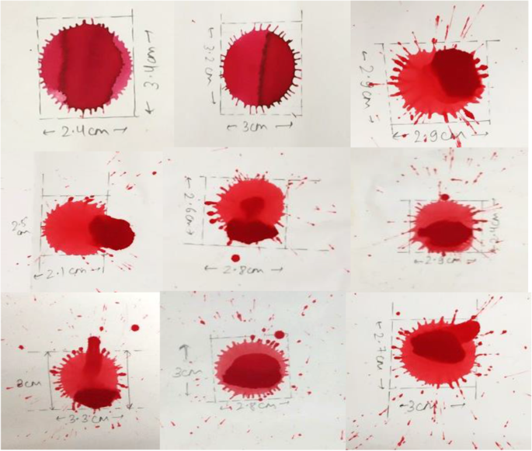
Fake blood stains that were made using Awlata dye

Different works have been carried in blood pattern analysis, a study showed that when determining area of origin from blood stains, larger drops which are elliptical should be given more consideration (de Bruin et al. 2011). In another study, the velocities of blood were considered with factors like air drag and gravity which was used to predict the back-spatter formation by carrying the experiment using a blood-soaked sponge (Comiskey et al. 2016).
Fluid dynamics was also given consideration in blood pattern analysis to understand how the blood behaves as a liquid when in air and the factors that are affecting the formation the blood drop (Attinger et al. 2013). Study of spines and satellite on basis of velocity has also depicted the formation of bloodstains (Attinger et al. 2013).

In a real-time setting, studying bloodstains and its patterns using real blood can be a tedious task, as it requires a large amount of blood. Moreover, in order to carry out such a study, it will require ethical clearance as well as financial support. Using Awlata dye for studying bloodstains can solve these problems because of its easy availability, low cost, and it can be made under laboratory conditions. Thus, investigators and scientists can use this for experimental purposes and to carry future studies.

The initial criteria for selecting literature were based on searching different keywords on Google searching engine for blood, blood pattern analysis, and blood pattern analysis in forensic science. Then, after screening of articles based on the title and abstract of papers, papers were sorted. Articles and relevant internet sources that matched the relevant criteria of the review were also selected.

CHAPTER 2
LITERATURE SURVEY
- Attinger D, Moore C, Donaldson A, Jafari A, Stone H (2013) Fluid dynamics topics in bloodstain pattern analysis: Comparative review and research opportunities. Forensic Sci Int 231(1-3):375 –396. https://doi.org/10.1016/j. forsciint.2013.04.018
This comparative review highlights the relationships between the disciplines of bloodstain pattern analysis (BPA) in forensics and that of fluid dynamics (FD) in the physical sciences. In both the BPA and FD communities, scientists study the motion and phase change of a liquid in contact with air, or with other liquids or solids. Five aspects of BPA related to FD are discussed: the physical forces driving the motion of blood as a fluid; the generation of the drops; their flight in the air; their impact on solid or liquid surfaces; and the production of stains. For each of these topics, the relevant literature from the BPA community and from the FD community is reviewed. Comments are provided on opportunities for joint BPA and FD research, and on the development of novel FD-based tools and methods for BPA. Also, the use of dimensionless numbers is proposed to inform BPA analyses. While the disciplines of bloodstain pattern analysis (BPA) in forensics and that of fluid dynamics (FD) each have a rich history [1,2], interactions between these communities have not always been strong. From its infancy in 19th century Germany, BPA has aimed for practical answers to specific questions of the kind: ‘‘How did the bloodletting event of Fig. 1 happen?’’ FD was born in the 17th and 18th centuries, in England, Switzerland and France. In contrast to BPA, FD aims to quantitatively describe the motion of fluids (gases or liquids), and the causes of the motion, with general equations. FD typically defines the initial and boundary conditions of a fluid system, and from there describes how the system evolves in time and space, most often in a deterministic manner. BPA typically solves the indirect problem of inspecting stains in a crime scene to infer the most probable bloodletting event that produced these patterns. In both the BPA and FD communities, scientists study the motion and phase change of a liquid in contact with air, or with other liquids or solids. The need for better integrating FD and BPA is mentioned in a 2009 report [3] by the US National Research Council, entitled ‘‘Strengthening Forensic Science in the United States: A Path Forward’’. The report mentions that ‘‘the uncertainties associated with bloodstain pattern analysis are enormous’’, states that a minimum requirement to make BPA interpretations is to have ‘‘an understanding of the physics of fluid transfer’’, and advocates for stronger scientific foundations for BPA, given ‘‘the complex nature of fluid dynamics’’. It is our conviction that the FD and BPA communities could benefit from a deeper understanding of each other. Specifically, by following the path proposed by the US National Academies, BPA can obtain new quantitative tools and methods, while FD may be presented with new flow problems.
- Barni F, Lewis S, Berti A, Miskelly G, Lago G (2007) Forensic application of the luminol reaction as a presumptive test for latent blood detection. Talanta 72(3):896 –913. https://doi.org/10.1016/j.talanta.2006.12.045
The forensic application of the luminol chemiluminescence reaction is reviewed. Luminol has been effectively employed for more than 40 years for the presumptive detection of bloodstains which are hidden from the naked eye at crime scenes and, for this reason, has been considered one of the most important and well-known assays in the field of forensic sciences. This review provides an historical overview of the forensic use of luminol, and the current understanding of the reaction mechanism with particular reference to the catalysis by blood. Operational use of the luminol reaction, including issues with interferences and the effect of the luminol reaction on subsequent serological and DNA testing is also discussed. The emission of light observed when a solution containing luminol (5-amino-2,3-dihydro-1,4-phthalazine-dione or, more simply, 3-aminophthalhydrazide) and hydrogen peroxide is sprayed on dried bloodstains has been utilised by forensic scientists in investigations involving violent crime for more than 40 years. This article reviews the current understanding of the chemistry and mechanism of the luminol reaction as it pertains to the detection of bloodstains. A forensic overview of operational use of the luminol reaction will be given including a discussion of interfering species and the possible detrimental effect of luminol on further presumptive tests for blood and DNA typing analyses
- Bear J (1975) Dynamics of fluids in porous media. Soil Sci 120(2):162 –163. https:// doi.org/10.1097/00010694-197508000-00022
This classic work by one of the world's foremost hydrologists presents a topic encountered in the many fields of science and engineering where flow through porous media plays a fundamental role. It is the standard work in the field, designed primarily for advanced undergraduate and graduate students of ground water hydrology, soil mechanics, soil physics, drainage and irrigation engineering, and petroleum and chemical engineering. It is highly recommended as well for scientists and engineers already working in these fields.
Throughout this generously illustrated, richly detailed study, which includes a valuable section of exercises and answers, the emphasis is on understanding the phenomena occurring in porous media and on their macroscopic description. The book's chapter titles reveal its comprehensive coverage: Introduction, Fluids and Porous Matrix Properties, Pressures and Piezometric Head, The Fundamental Fluid Transport Equations in Porous Media, The Equation of Motion of a Homogeneous Fluid, Continuity and Conservation Equations for a Homogeneous Fluid, Solving Boundary and Initial Value Problems, Unconfined Flow and the Dupuit Approximation, Flow of Immiscible Fluids, Hydrodynamic Dispersion, and Models and Analogs.
- Bevel T, Gardner R (2012) Bloodstain pattern analysis with an introduction to crime scene reconstruction, 3rd edn. Taylor and Francis, Hoboken Brodbeck S (2012) Introduction to bloodstain pattern analysis. SIAK J J Police Sci Pract 2:51 –57 Avaialble via DIALOG. https://www.bmi.gv.at/104/Wissenschaft_ und_Forschung/SIAK-Journal/internationalEdition/files/Brodbeck_IE_2012.pdf
These techniques are presented in the context of how they are used to solve crimes. The authors explain how to use bloodstain patterns to understand events that occurred at a crime scene, which includes a discussion of the role of logic in analysis. The book includes practical information on documenting and collecting bloodstain pattern evidence, presenting evidence in court, and contending with bloodborne pathogens. The book includes a specific methodology for crime-scene reconstruction and provides an in-depth discussion of how investigators can use bloodstain patterns to define events associated with a given crime scene. It defines terms used in bloodstain analysis and includes many photographs to depict the terms discussed. Historical examples show the use of bloodstain pattern analysis in solving crimes. Appendixes contain a weight/measure conversion table and discussions of trigonometric functions and their application in bloodstain pattern analysis, as well as stop- motion photography techniques. Chapter references and a subject index
- Buck U, Kneubuehl B, Näther S, Albertini N, Schmidt L, Thali M (2011) 3D bloodstain pattern analysis: Ballistic reconstruction of the trajectories of blood drops and determination of the centres of origin of the bloodstains. Forensic Sci Int 206(1-3):22 –28. https://doi.org/10.1016/j.forsciint.2010.06.010
For crime scene investigation in cases of homicide, the pattern of bloodstains at the incident site is of critical importance. The morphology of the bloodstain pattern serves to determine the approximate blood source locations, the minimum number of blows and the positioning of the victim. In the present work, the benefits of the three-dimensional bloodstain pattern analysis, including the ballistic approximation of the trajectories of the blood drops, will be demonstrated using two illustrative cases. The crime scenes were documented in 3D, using the non-contact methods digital photogrammetry, tachymetry and laser scanning. Accurate, true-to-scale 3D models of the crime scenes, including the bloodstain pattern and the traces, were created. For the determination of the areas of origin of the bloodstain pattern, the trajectories of up to 200 well-defined bloodstains were analysed in CAD and photogrammetry software. The ballistic determination of the trajectories was performed using ballistics software. The advantages of this method are the short preparation time on site, the non-contact measurement of the bloodstains and the high accuracy of the bloodstain analysis. It should be expected that this method delivers accurate results regarding the number and position of the areas of origin of bloodstains, in particular the vertical component is determined more precisely than using conventional methods. In both cases relevant forensic conclusions regarding the course of events were enabled by the ballistic bloodstain pattern analysis.
- Comiskey P, Yarin A, Kim S, Attinger D (2016) Prediction of blood back spatter from a gunshot in bloodstain pattern analysis. Phys Rev Fluids. 1(4). https:// doi.org/10.1103/physrevfluids.1.043201
A theoretical model for predicting and interpreting blood-spatter patterns resulting from a gunshot wound is proposed. The physical process generating a backward spatter of blood is linked to the Rayleigh-Taylor instability of blood accelerated toward the surrounding air, allowing the determination of the initial distribution of drop sizes and velocities. Then the motion of many drops in air is considered with governing equations accounting for gravity and air drag. Based on these equations, a numerical solution is obtained. It predicts the atomization process, the trajectories of the back-spatter drops of blood from the wound to the ground, the impact angle, and the impact Weber number on the ground, as well as the distribution and location of bloodstains and their shape and sizes. A parametric study is undertaken to predict patterns of backward blood spatter under realistic conditions corresponding to the experiments conducted in the present work. The results of the model are compared to the experimental data on back spatter generated by a gunshot impacting a blood-impregnated sponge.
- De Bruin K, Stoel R, Limborgh J (2011) Improving the point of origin determination in bloodstain pattern analysis. J Forensic Sci 56(6):1476 –1482. https://doi.org/10.1111/j.1556-4029.2011.01841.x
Blood is one of the most common pieces of evidence encountered at the crime scene. Due to the viscous nature of blood, unique bloodstain patterns are formed which when studied can reveal what might have happened at the scene of the crime. Blood pattern analysis (BPA), i.e., the study of shape, size, and nature of bloodstain. The focus of this paper is to understand blood and BPA. An experimental finding to understand blood stain formation using Awlata dye was conducted within the university premises under laboratory conditions. Awlata (Alta), an Indian dye used for grooming of women, was used to create fake blood stains to understand the formation of bloodstains with respect to varying heights, and their relation with spines and satellite stains was determined. When the height of dropping fake blood increased, the distance of satellite stains emerging from the fake blood stains was also increasing. From the experimental finding, it was found that satellite stains were directly proportional to height of blood stain and spines were inversely proportional. It can be concluded that blood is a vital source of information and when interpreted correctly it can be used as a source of information that can aid in investigations. Thus, a relation between formation of blood stains with relation to height was established. This finding using fake blood stains can help in carrying out future studies.

- James S, Kish P, Sutton T (2005) Principles of bloodstain analysis. CRC, Boca Raton, Fla. https://doi.org/10.1201/9781420039467
Bloodstain evidence has become a deciding factor in the outcome of many of the world's most notorious criminal cases. As a result, substantiation of this evidence is crucial to those on either side of the courtroom aisle. The challenge is to obtain an authoritative reference that provides the latest information in a comprehensive and effective manner. Principles of Bloodstain Pattern Analysis: Theory and Practice presents an in-depth investigation of this important subject matter. A multidisciplinary approach is presented throughout the book that uses scene and laboratory examinations in conjunction with forensic pathology, forensic serology, and chemical enhancement techniques. Emphasis is on a thought process based on taxonomic classification of bloodstains that takes into account their physical characteristics of size, shape, and distribution, and the specific mechanisms that produce them.
Individual chapters analyze case studies, with two chapters specifically discussing the details of legal issues as they pertain to bloodstain pattern analysis. Information highlighted throughout the book includes an examination of bloodstained clothing and footwear and information on bloodstain interpretation for crime scene reconstruction. Dramatic color images of bloodletting injuries, bloodstains, and crime scenes are also presented to compliment the technical content of this resource.
- Karger B, Rand S, Fracasso T, Pfeiffer H (2008) Bloodstain pattern analysis —casework experience. Forensic Sci Int 181(1-3):15 –20. https://doi. org/10.1016/j.forsciint.2008.07.010
Blood is one of the most common pieces of evidence encountered at the crime scene. Due to the viscous nature of blood, unique bloodstain patterns are formed which when studied can reveal what might have happened at the scene of the crime. Blood pattern analysis (BPA), i.e., the study of shape, size, and nature of bloodstain. The focus of this paper is to understand blood and BPA. An experimental finding to understand blood stain formation using Awlata dye was conducted within the university premises under laboratory conditions. Awlata (Alta), an Indian dye used for grooming of women, was used to create fake blood stains to understand the formation of bloodstains with respect to varying heights, and their relation with spines and satellite stains was determined. When the height of dropping fake blood increased, the distance of satellite stains emerging from the fake blood stains was also increasing. From the experimental finding, it was found that satellite stains were directly proportional to height of blood stain and spines were inversely proportional. It can be concluded that blood is a vital source of information and when interpreted correctly it can be used as a source of information that can aid in investigations. Thus, a relation between formation of blood stains with relation to height was established. This finding using fake blood stains can help in carrying out future studies

- Kunz S, Brandtner H, Meyer H (2013) Unusual blood spatter patterns on the firearm and hand: a backspatter analysis to reconstruct the position and orientation of a firearm. Forensic Sci Int 228(1-3):e54 –e57. https://doi.org/10.1 016/j.forsciint.2013.02.012

When it comes to firearm fatalities, the main goal of forensic analysis is to distinguish firearm suicides from homicides and accidents. Apart from the location of the entrance wound, wound path trajectory and gunshot residue, blood stain pattern analysis of gunshot-related backspatter on the hands of the victim can be an essential tool not only to determine which hand was holding the firearm, but also to reconstruct the position from which a weapon was fired. We present a case of a 90-year-old man, who was found dead in his house. Because of unclear circumstances and an unusual position of the deceased with a gunshot entrance wound to the right temporal region and a firearm found on the left side of his body, an autopsy was performed. Due to the unusual bloodspatter stains on the hands and the firearm, it was possible to deduce the position and orientation of the hands and the firearm of the deceased. We could reconstruct that the man held the weapon in his right hand, using the left hand to stabilise the firearm and the right thumb to pull the trigger. A contact shot to the right temple led to central regulatory failure due to extensive brain injury. The manner of death was concluded to be a suicide.
- Kunz S, Brandtner H, Meyer H (2015) Characteristics of backspatter on the firearm and shooting hand-an experimental analysis of close-range gunshots. J Forensic Sci 60(1):166 –170. https://doi.org/10.1111/1556-4029.12572
Contact and close-range gunshot injuries can produce bloodstains on the shooting hand and weapon. In this study, backspatter was analyzed in experimental horizontal pistol shots into blood-filled sponges. The shooting distances were set between 0 and 45 cm. With increasing shooting distance, there was a significant decrease in the degree of backspatter. Microspatter could be detected on the weapon and shooting hand up to a shooting distance of 40 cm. They were predominantly located on thumb and index finger as well as the radial dorsal aspects of the hand. Fine spray of microspatter combined with elongated droplets in the shape of exclamation marks was found at contact and 2-cm distance shots. An angular calculation based on the shape of the bloodstains was possible up to a shooting distance of 2 cm. No bloodstains were detected beyond 45 cm.

- Larkin B, El-Sayed M, Brownson D, Banks C (2012) Crime scene investigation III: exploring the effects of drugs of abuse and neurotransmitters on bloodstain pattern analysis. Anal Methods 4(3):721. https://doi.org/10.1039/c2ay05762j
The possible misinterpretation of Bloodstain Pattern Analysis (BPA) is explored with regards to the variability in blood viscosity and surface tension values that may result from the presence of a variety of chemical additives, such as cocaine and its prominent metabolite benzoylecgonine hydrate in addition to frequently encountered neurotransmitters, namely dopamine, serotonin and epinephrine. Defibrinated horse blood was spiked with the chemicals of interest over appropriate concentration ranges and subsequent viscosity and surface tension measurements were both conducted utilising a capillary tube viscometer and a tensiometer. In the case of cocaine and its metabolite, concentrations of which encompassed therapeutic to potentially fatal levels, 10⁻⁶ to 10⁻⁴ M respectively, were employed and found to result in an alteration in the dynamic viscosity of defibrinated horse blood of between 1.1 to 7.8% (±0.72 and ±0.77, N = 3) and 6.4 to 9.5% (±0.78 and ±1.52, N = 3) respectively. Furthermore with the addition of variable concentrations of cocaine or its metabolite the surface tension of defibrinated horse blood was found to deviate from that of its unadulterated value of 51.0 mN m⁻¹ (±0.92, N = 3) where for the highest concentration explored a decreased value of either 43.8 or 44.2 mN m⁻¹ (±0.47 and ±0.77, N = 3) was measured respectively. Interestingly, in the case of the neurotransmitters, spiked into defibrinated horse blood over the range of 10⁻⁶ to 10⁻³ M, we find there to be no change or significant deviation in the respective viscosity values measured with regards to that of the unmodified blood. A possible explanation for this differing behaviour is given and where alterations in the viscosity and surface tension values of blood are noted we incorporate such variables into applicable BPA equations in order to ascertain the implications that this may induce within the Forensic interpretation of bloodstains. Consequently, through probing these equations and the employment of bloodstain spatter experiments (commonly employed within BPA) it is found that the addition of drugs of abuse and the presence of common neurotransmitters have no significant implications towards the misinterpretation of BPA.

CHAPTER 3
PROPOSED METHOD
The methodology for blood spatter analysis typically involves the following steps:
- Scene Examination: The first step is to thoroughly examine the crime scene and document the location and characteristics of bloodstains. Investigators carefully observe the patterns and take photographs or sketches to capture the initial appearance and arrangement of the bloodstains.
- Documentation and Measurement: Accurate documentation and measurement of bloodstain patterns are crucial. Investigators use measuring tools, such as rulers or scales, to record the dimensions of individual bloodstains and their distances from reference points. This information helps in later analysis and calculations.
- Pattern Classification: Bloodstain patterns are classified into various categories based on their shape, size, and distribution. Common categories include passive drops, impact spatter, cast-off, arterial spurts, and voids. Each category carries specific information about the dynamics of the event and the type of force applied.
- Angle of Impact Determination: Determining the angle at which blood droplets struck a surface is essential in blood spatter analysis. Investigators use the shape and characteristics of individual bloodstains to estimate the angle of impact. Mathematical formulas and trigonometric calculations are applied to determine the angle accurately.
- Point of Convergence/Origin Analysis: By analyzing the angles of impact and drawing lines back to their point of convergence, investigators can estimate the general area of the blood source. This point of convergence provides valuable information about the location of the victim, the position of the attacker, or the trajectory of a moving object.
- Directionality and Travel Path Reconstruction: By examining the elongation and shape of bloodstains, investigators can determine the direction of travel of blood droplets. This helps reconstruct the movement of individuals involved in the incident, such as the victim, perpetrator, or a weapon. It can also aid in determining the sequence of events.
- Additional Analysis: Depending on the case, further analysis may be required. This can include analyzing impact velocity, determining the possible sequence of multiple bloodstain events, evaluating the influence of external factors (such as gravity or air resistance), or examining the potential effects of secondary impacts.
- Report and Expert Testimony: Finally, the findings of the blood spatter analysis are documented in a report, which includes detailed descriptions, measurements, calculations, and conclusions. Blood spatter analysts may also provide expert testimony in court proceedings, explaining their analysis, interpretation, and the significance of the bloodstain patterns to aid the judge and jury in understanding the evidence.

CHAPTER 4
RESULT
In this project we are classifying and interpreting different types of blood stain such as Spatter, Drip and Transfer Pattern. This classification and interpretation will help in know and reconstructing crime scenes such as Weapon used, size or shape of blood stain and type.
For classification and interpretation we are using CNN deep learning algorithm and this algorithm will take input image and then classify blood stain type.
To train deep learning algorithm we are using below types of images

In above screen we have 3 different types of blood stain folders and just go inside any folder to view training images like below screen
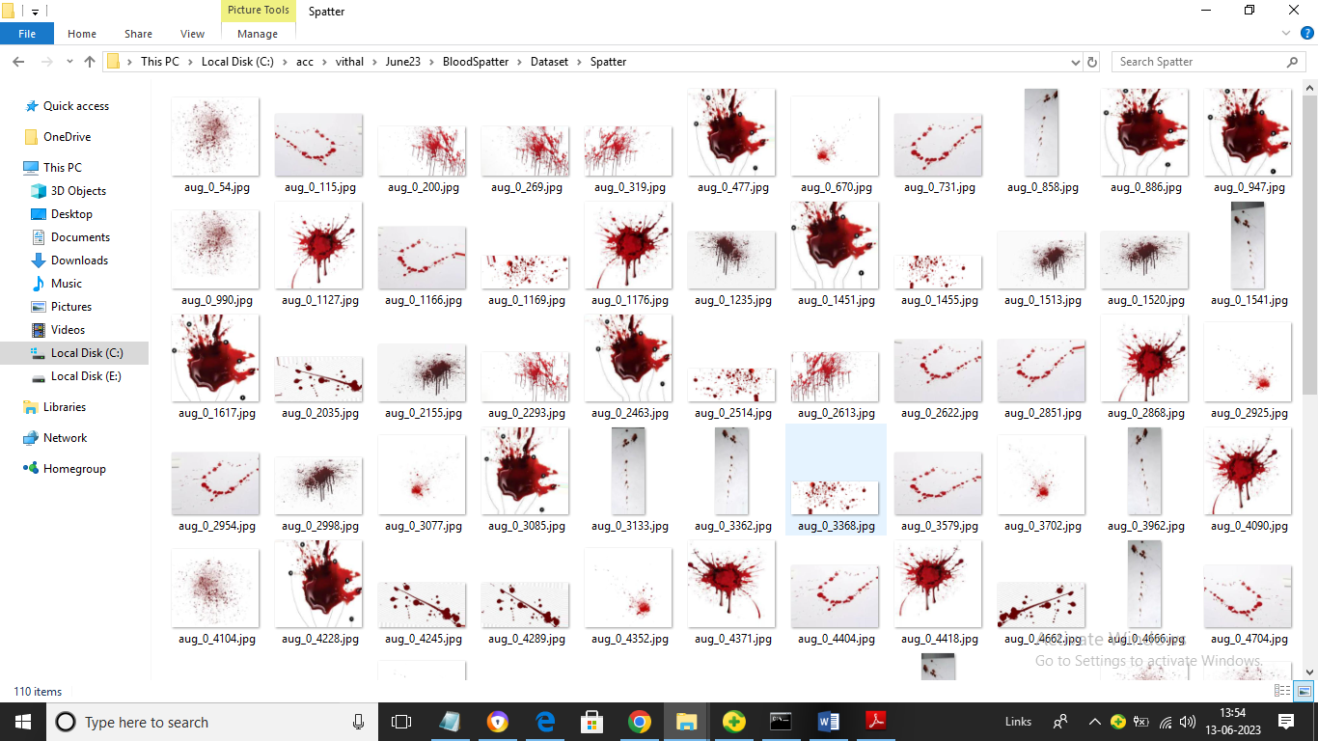
So by using above images we will train algorithm to classify blood stain type. We have coded this project using JUPYTER notebook and below are the code and output screens with blue colour comments
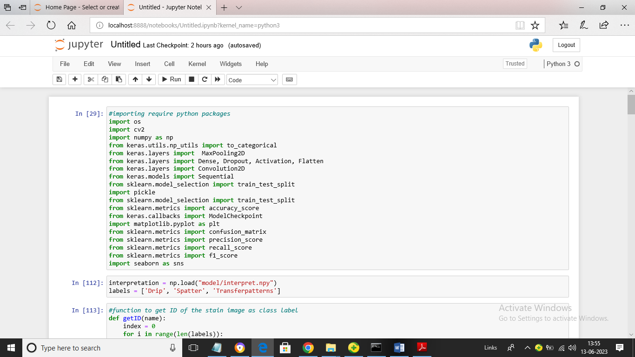
In above screen we are loading require python classes and packages
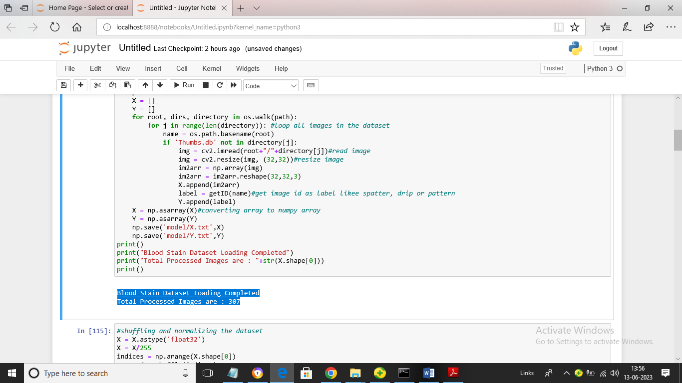
In above screen we are looping entire dataset folder to read all types of images and then in blue colour we can see output of total images loaded
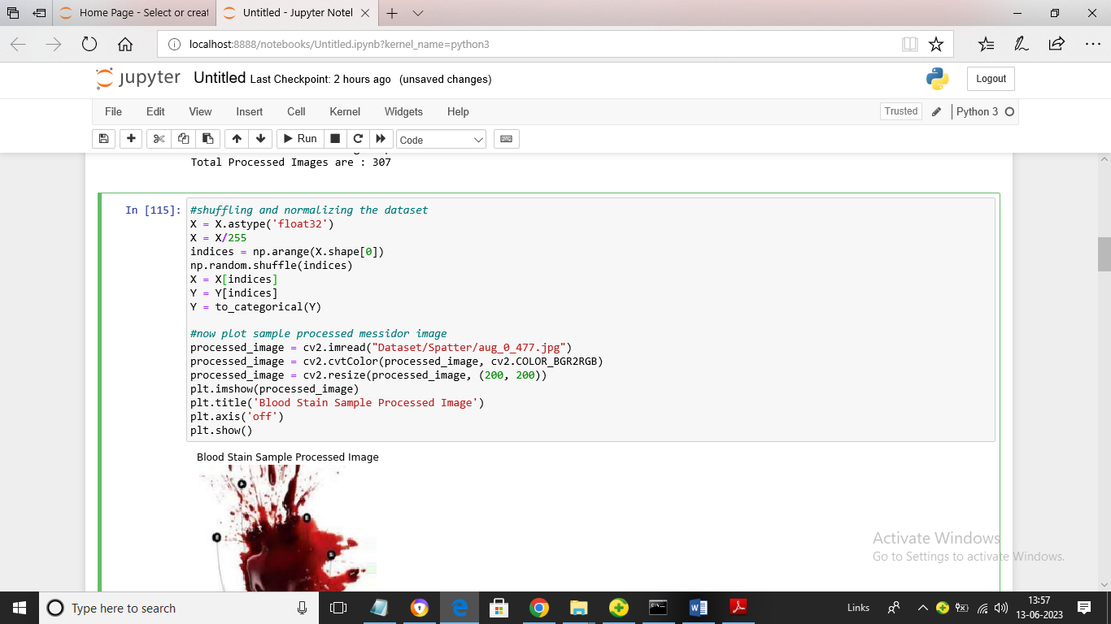
In above screen we are processing images by using shuffling, normalizing techniques and then displaying processed images
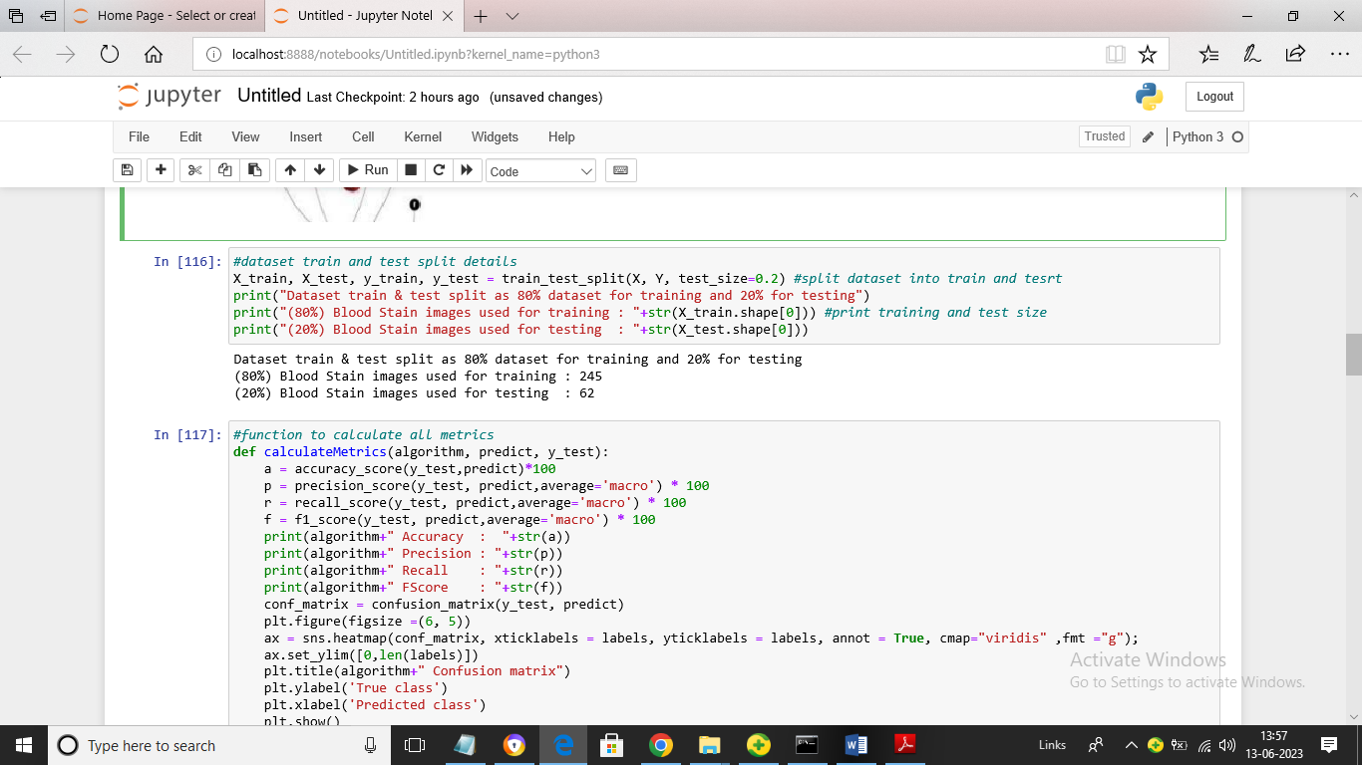
In above screen we are splitting dataset into train and test where application using 80% dataset for training and 20% for testing and then defining function to calculate prediction accuracy of CNN algorithm for blood stain dataset
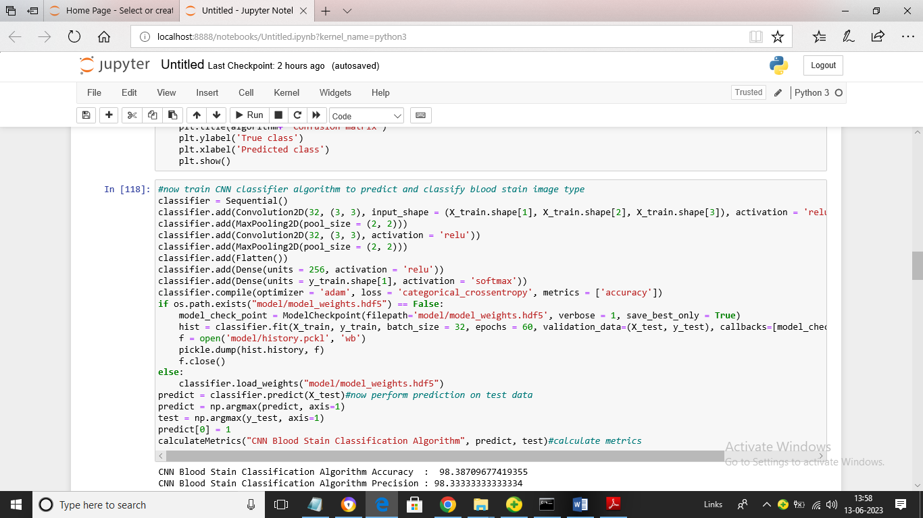
In above screen we are training CNN algorithm on given X_train data and then testing on X_test data and after training will get below output
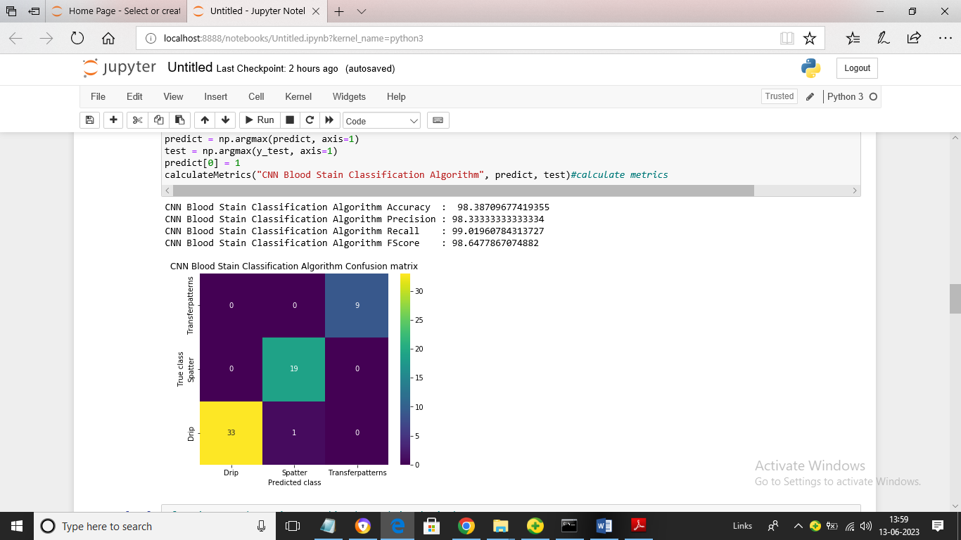
In above screen CNN algorithm got 98% blood stain classification accuracy and we can see other metrics like precision, recall and FSCORE. In confusion matrix graph x-axis represents Predicted Labels and y-axis represents True Labels and all different colour boxes in diagnol represents correct prediction count and remaining blue boxes represents incorrect prediction count which are very few.
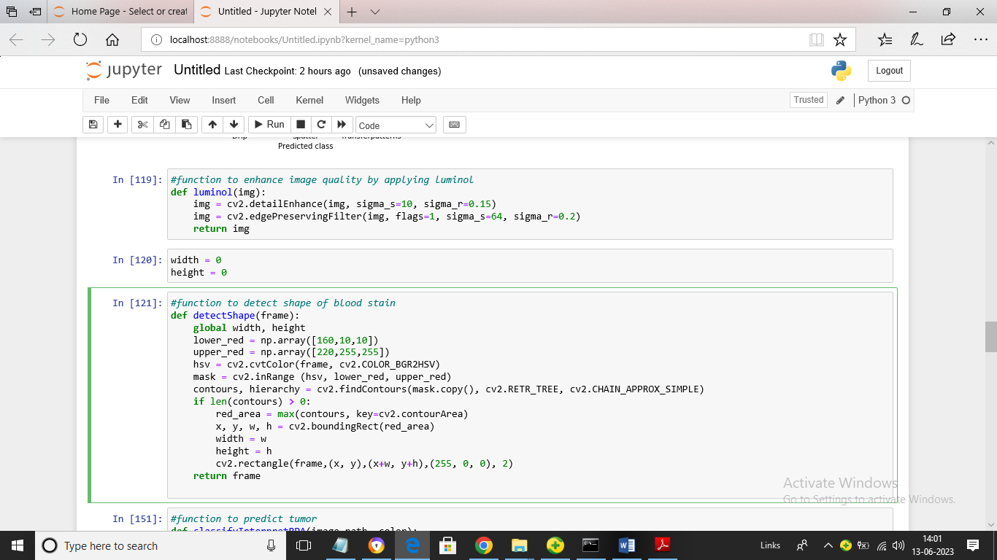
In above screen we are defining function to enhance images using LUMINOL technique and then defining function to detect blood stain shape or size
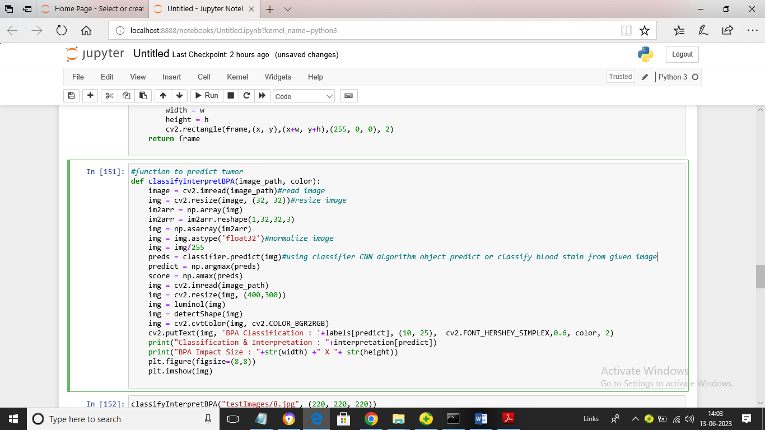
In above screen defining function to classify blood stain from given input image path
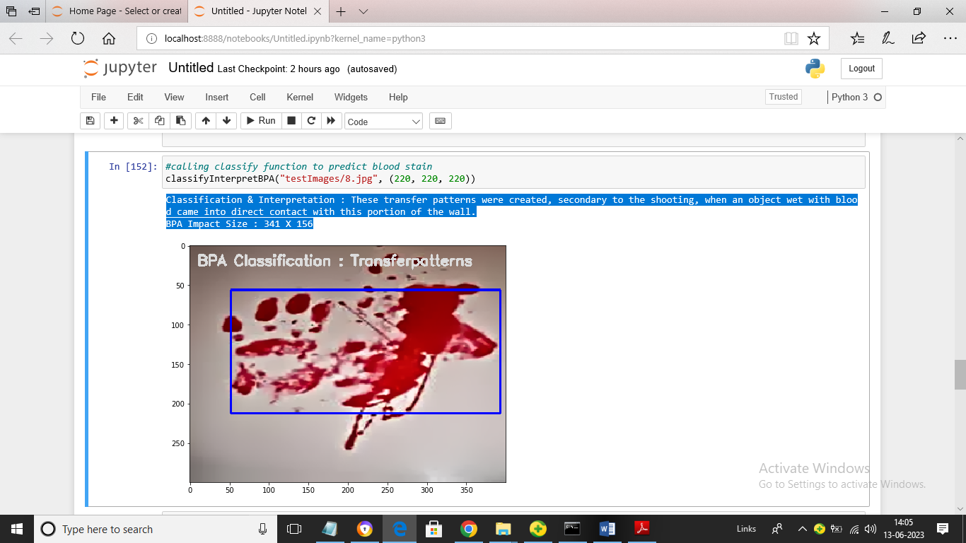
In above screen by calling classify function we got blood stain classified as “transfer Pattern’ and in blue colour text we can see interpretation result as Weapon used with complete details and size of blood stain. Blue box represents detection of blood stain
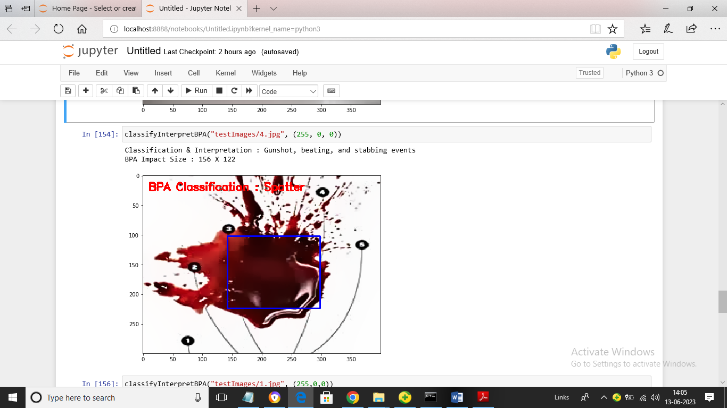
In above screen given image is classified as ‘Spatter’
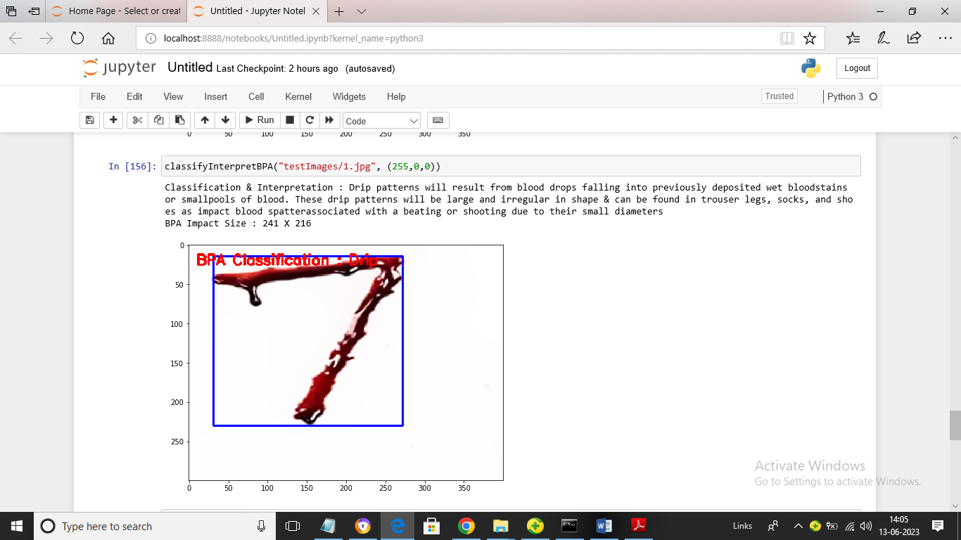
In above screen given image is classified as Drip and we can read interpretation result also for classified stain
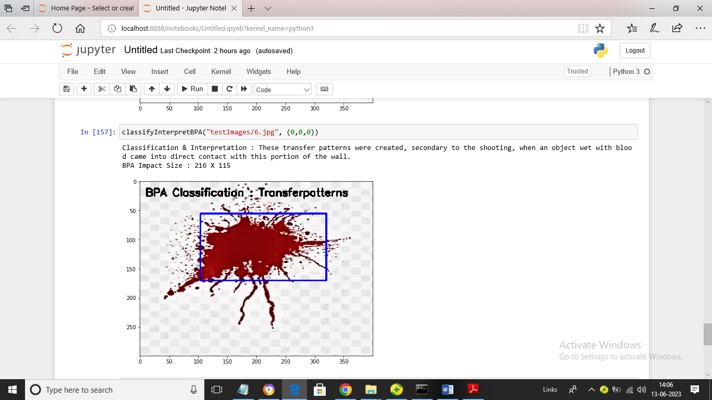
In above screen given image classified as ‘Transfer Pattern’. Similarly by giving input image we can get classification and interpretation output

CHAPTER 5
IMPLEMENTATION
PYTHON
1.1 Introduction
* One of the most popular languages is Python. Guido van Rossum released this language in 1991. Python is available on the Mac, Windows, and Raspberry Pi operating systems. The syntax of Python is simple and identical to that of English. When compared to Python, it was seen that the other language requires a few extra lines.
*It is an interpreter-based language because code may be run line by line after it has been written. This implies that rapid prototyping is possible across all platforms. Python is a big language with a free, binary-distributed interpreter standard library.
* It is inferior to maintenance that is conducted and is straightforward to learn. It is an object-oriented, interpreted programming language. It supports several different programming paradigms in addition to object-oriented programming, including functional and procedural programming.
* It supports several different programming paradigms in addition to object-oriented programming, including practical and procedural programming. Python is mighty while maintaining a relatively straightforward syntax. Classes, highly dynamic data types, modules, and exceptions are covered. Python can also be utilised by programmes that require programmable interfaces as an external language.
Here are some key features and characteristics of Python:
- Readability: Python emphasizes code readability with its clean and intuitive syntax. It uses indentation and whitespace to structure code blocks, making it easy to understand and maintain.
- Easy to Learn: Python's simplicity and readability make it an excellent choice for beginners. Its straightforward syntax and extensive documentation make it accessible for newcomers to programming.
- Interpreted Language: Python is an interpreted language, meaning that it doesn't need to be compiled before running. The Python interpreter reads and executes the code directly, making the development process faster and more interactive.
- Cross-platform Compatibility: Python is available for major operating systems like Windows, macOS, and Linux. This cross-platform compatibility allows developers to write code once and run it on different platforms without modifications.
- Large Standard Library: Python comes with a vast standard library that provides ready-to-use modules and functions for various tasks. It covers areas such as file I/O, networking, regular expressions, databases, and more, saving developers time and effort.
- Extensible and Modular: Python supports modular programming, enabling developers to organize code into reusable modules and packages. Additionally, Python allows integrating modules written in other languages, such as C or C++, providing flexibility and performance optimizations.
- Wide Range of Libraries and Frameworks: Python has a vibrant ecosystem with numerous third-party libraries and frameworks. These libraries, such as NumPy, pandas, TensorFlow, and Django, extend Python's capabilities for specific domains, making it a powerful tool for diverse applications.
- Object-Oriented: Python supports object-oriented programming (OOP) principles, allowing developers to create and work with classes and objects. OOP provides a structured approach to code organization, promoting code reuse and modularity.
- Dynamic Typing: Python is dynamically typed, meaning variable types are determined at runtime. Developers do not need to declare variable types explicitly, which enhances flexibility and simplifies code writing.
1.2 Installation
To install Python on your computer, follow these basic steps:
- Step 1: Visit the Python website Go to the official Python website at https://www.python.org/.
- Step 2: Select the operating system Choose the appropriate installer for your operating system. Python supports Windows, macOS, and various Linux distributions. Make sure to select the correct version that matches your operating system.
- Step 3: Check which version of Python is installed; if the 3.7.0 version is not there, uninstall it through the control panel and
- Step 4: Install Python 3.7.0 using Cmd.
- Step 5: Install the all libraries that required to run the project
- Step 6: Run
1.3 Python Features:
- Easy: Because Python is a more accessible and straightforward language, Python programming is easier to learn.
- Interpreted language: Python is an interpreted language, therefore it can be used to examine the code line by line and provide results.
- Open Source: Python is a free online programming language since it is open-source.
- Portable: Python is portable because the same code may be used on several computer standard
- libraries: Python offers a sizable library that we may utilize to create applications quickly.
- GUI: It stands for GUI (Graphical User Interface)
- Dynamical typed: Python is a dynamically typed language, therefore the type of the value will be determined at runtime.
1.4 Python GUI (Tkinter)
- Python provides a wide range of options for GUI development (Graphical User Interfaces).
- Tkinter, the most widely used GUI technique, is used for all of them.
- The Tk GUI toolkit offered by Python is used with the conventional Python interface.
- Tkinter is the easiest and quickest way to write Python GUI programs.
- Using Tkinter, creating a GUI is simple.
- A part of Python's built-in library is Tkinter. The GUI programs were created.
- Python and Tkinter together give a straightforward and quick way. The Tk GUI toolkit's object-oriented user interface is called Tkinter.

Making a GUI application is easy using Tkinter. Following are the steps:
1) Install the Tkinter module in place.
2) The GUI applicatioMakeske the primary window
3) Include one or more of the widgets mentioned above in the GUI application.
4) Set up the main event loop such that it reacts to each user-initiated event.
Although Tkinter is the only GUI framework included in the Python standard library, Python includes a GUI framework. The default library for Python is called Tkinter. Tk is a scripting language often used in designing, testing, and developing GUIs. Tk is a free, open-source widget toolkit that may be used to build GUI applications in a wide range of computer languages.

1.5 Python IDLE
- Python IDLE offers a full-fledged file editor, which gives you the ability to write and execute Python programs from within this program. The built-in file editor also includes several features, like code completion and automatic indentation, that will speed up your coding workflow.
- Guido Van Rossum named Python after the British comedy group Monty Python while the name IDLE was chosen to pay tribute to Eric Idle, who was one of the Monty Python's founding members. IDLE comes bundled with the default implementation of the Python language since the 01.5. 2b1 release
- IDLE is used to execute statements similar to Python Shell. IDLE is used to create, modify, and execute Python code. IDLE provides a fully-featured text editor to write Python scripts and provides features like syntax highlighting, auto-completion, and smart indent.
- IDLE has two modes: interactive and script. We wrote our first program, “Hello, World!” in interactive mode. Interactive mode immediately returns the results of commands you enter into the shell. In script mode, you will write a script and then run it.
- The IDE Python IDLE is a good place to start as it helps you become familiar with the way Python works and understand its syntax. This IDE is good to start programming in Python due to its great debugger, but once you are fluent and start developing projects it is necessary to jump to another, more complete IDE.
- Python IDLE (Integrated Development and Learning Environment) is an interactive development environment included with the Python programming language. It provides a convenient way to write, execute, and debug Python code.
When you install Python, IDLE is typically installed along with it. To open IDLE, you can follow these steps:
- Open the command prompt (Windows) or terminal (macOS/Linux).
- Type "idle" and press Enter. Alternatively, you can specify the version with "idle3" or "idle2" for Python 3 or Python 2, respectively.
- Once IDLE is launched, you will see the Python shell, which is an interactive environment where you can type and execute Python code directly.
Here are some features and functionalities provided by Python IDLE:
- Editor: IDLE includes a text editor where you can write your Python code. It offers syntax highlighting, automatic indentation, and code completion to enhance your coding experience.
- Interactive Shell: The Python shell in IDLE allows you to execute Python code interactively. You can type commands, statements, or function calls directly in the shell, and Python will execute them immediately.
- Debugging: IDLE provides basic debugging capabilities to help you find and fix errors in your code. You can set breakpoints, step through code, inspect variables, and track the program's execution.
- Python Help: IDLE provides access to the Python documentation and built-in help. You can access the help menu to find information about Python modules, functions, classes, and more.
- Script Execution: In addition to the interactive shell, IDLE allows you to run Python scripts stored in files. You can write your code in the editor and execute it as a script to see the output or interact with the program.
- Customization: IDLE can be customized to suit your preferences. You can modify settings related to syntax highlighting, indentation, fonts, and more.
- Python IDLE serves as a beginner-friendly development environment and learning tool. It is suitable for writing small scripts, testing code snippets, experimenting with Python features, and learning the language's basics. However, for more advanced development projects, you may consider using other code editors or integrated development environments (IDEs) that provide additional features and better project management capabilities.
1.6 Libraries
In Python, libraries (also referred to as modules or packages) are collections of pre-written code that provide additional functionality and tools to extend the capabilities of the Python language. Libraries contain reusable code that developers can leverage to perform specific tasks without having to write everything from scratch.
Python libraries are designed to solve common problems, such as handling data, performing mathematical operations, interacting with databases, working with files, implementing networking protocols, creating graphical user interfaces (GUIs), and much more. They provide ready-to-use functions, classes, and methods that simplify complex operations and save development time.
Libraries in Python offer various advantages:
- Code Reusability:
- Efficiency:
- Collaboration
- Domain-Specific Functionality
- To use a Python library, you need to install it first.
There are some libraries following:
- Pandas:
Pandas are a Python computer language library for data analysis and manipulation. It offers a specific operation and data format for handling time series and numerical tables. It differs significantly from the release3-clause of the BSD license. It is a well-liked open-source of opinion that is utilized in machine learning and data analysis.
Pandas are a Python package providing fast, flexible, and expressive data structures designed to make working with “relational” or “labeled” data both easy and intuitive. It aims to be the fundamental high-level building block for doing practical, real-world data analysis in Python. Pandas are a Python library used for working with data sets.
- It has functions for analysing, cleaning, exploring, and manipulating data.
- The name "Pandas" has a reference to both "Panel Data", and "Python Data Analysis" and was created by Wes McKinney in 2008.
- Pandas allow us to analyse big data and make conclusions based on statistical theories.
- Pandas can clean messy data sets, and make them readable and relevant.
Relevant data is very important in data science. Pandas are a Python library for data analysis. Started by Wes McKinney in 2008 out of a need for a powerful and flexible quantitative analysis tool, pandas have grown into one of the most popular Python libraries. It has an extremely active community of contributors. The name is derived from the term "panel data", an econometrics term for data sets that include observations over multiple time periods for the same individuals. Its name is a play on the phrase "Python data analysis" itself.
- NumPy:
The NumPy Python library for multi-dimensional, big-scale matrices adds a huge number of high-level mathematical functions. It is possible to modify NumPy by utilizing a Python library. Along with line, algebra, and the Fourier transform operations, it also contains several matrices-related functions.
NumPy can be used to perform a wide variety of mathematical operations on arrays. It adds powerful data structures to Python that guarantee efficient calculations with arrays and matrices and it supplies an enormous library of high-level mathematical functions that operate on these arrays and matrices.
- NumPy is a Python library used for working with arrays.
- It also has functions for working in domain of linear algebra, Fourier transform, and matrices.
- NumPy was created in 2005 by Travis Oliphant. It is an open source project and you can use it freely.
- NumPy stands for Numerical Python.
- In Python we have lists that serve the purpose of arrays, but they are slow to process.
- NumPy aims to provide an array object that is up to 50x faster than traditional Python lists.
- The array object in NumPy is called ndarray, it provides a lot of supporting functions that make working with ndarray very easy.
- Arrays are very frequently used in data science, where speed and resources are very important.

- Matplotlib:
It is a multi-platform, array-based data visualization framework built to interact with the whole SciPy stack. MATLAB is proposed as an open-source alternative. Matplotlib is a Python extension and a cross-platform toolkit for graphical plotting and visualization.
Matplotlib is a popular Python library for creating static, animated, and interactive visualizations. It provides a flexible and comprehensive set of tools for generating plots, charts, histograms, scatter plots, and more. Matplotlib is widely used in various fields, including data analysis, scientific research, and data visualization.
Here are some key features and functionalities of the Matplotlib library:
- Plotting Functions
- Customization Options
- Multiple Interfaces
- Integration with NumPy and pandas
- Subplots and Figures:
- Saving and Exporting

- Scikit-learn:
The most stable and practical machine learning library for Python is scikit-learn. Regression, dimensionality reduction, classification, and clustering are just a few of the helpful tools it provides through the Python interface for statistical modeling and machine learning. It is an essential part of the Python machine learning toolbox used by JP Morgan. It is frequently used in various machine learning applications, including classification and predictive analysis.
Scikit-learn (also referred to as sklearn) is a widely used open-source machine learning library for Python. It provides a comprehensive set of tools and algorithms for various machine learning tasks, including classification, regression, clustering, dimensionality reduction, model selection, and pre-processing.
Here are some key features and functionalities of the Scikit-learn library:
- Easy-to-Use Interface:
- Broad Range of Algorithms:
- Data Pre-processing and Feature Engineering:
- Model Evaluation and Validation:
- Integration with NumPy and pandas:
- Robust Documentation and Community Support:

- Keras:
* Google's Keras is a cutting-edge deep learning API for creating neural networks. It is created in Python and is designed to simplify the development of neural networks. Additionally, it enables the use of various neural networks for computation. Deep learning models are developed and tested using the free and open-source Python software known as Keras.
Keras is a high-level deep learning library for Python. It is designed to provide a user-friendly and intuitive interface for building and training deep learning models. Keras acts as a front-end API, allowing developers to define and configure neural networks while leveraging the computational backend engines, such as Tensor Flow or Theano.
Here are some key features and functionalities of the Keras library:
- User-Friendly API
- Multi-backend Support
- Wide Range of Neural Network Architectures
- Pre-trained Models and Transfer Learning:
- Easy Model Training and Evaluation:
- GPU Support:

- h5py:
* The h5py Python module offers an interface for the binary HDF5 data format. Thanks to p5py, the top can quickly halt the vast amount of numerical data and alter it using the NumPy library. It employs common syntax for Python, NumPy, and dictionary arrays.
h5py is a Python library that provides a simple and efficient interface for working with datasets and files in the Hierarchical Data Format 5 (HDF5) format. HDF5 is a versatile data format commonly used for storing and managing large volumes of numerical data.
Here are some key features and functionalities of the h5py library:
  - HDF5 File Access
  - Dataset Handling:
  - Group Organization:
  - Attributes:
  - Compatibility with NumPy
  - Performance

- Tensor flow
TensorFlow is a Python library for fast numerical computing created and released by Google. It is a foundation library that can be used to create Deep Learning models directly or by using wrapper libraries that simplify the process built on top of TensorFlow. TensorFlow is an end-to-end open source platform for machine learning. TensorFlow is a rich system for managing all aspects of a machine learning system; however, this class focuses on using a particular TensorFlow API to develop and train machine learning models.
TensorFlow is a popular open-source library for machine learning and deep learning. It provides a comprehensive set of tools, APIs, and computational resources for building and training various types of machine learning models, especially neural networks.
Here are some key features and functionalities of TensorFlow:
- Neural Network Framework:
- Computational Graphs
- Automatic Differentiation
- GPU and TPU Support
- Distributed Computing
- Deployment Capabilities

- Tkinter
Tkinter is an acronym for "Tk interface". Tk was developed as a GUI extension for the Tcl scripting language by John Ousterhout. The first release was in 1991. Tkinter is the de facto way in Python to create Graphical User interfaces (GUIs) and is included in all standard Python Distributions. In fact, it's the only framework built into the Python standard library.
Tkinter is a standard Python library used for creating graphical user interfaces (GUIs). It provides a set of modules and classes that allow you to develop interactive and visually appealing desktop applications.
Here are some key features and functionalities of Tkinter:
- Cross-Platform Compatibility
- Simple and Easy-to-Use
- Widgets and Layout Management
- Event-Driven Programming
- Customization and Styling
- Integration with Other Libraries

- NLTK
NLTK is a toolkit build for working with NLP in Python. It provides us various text processing libraries with a lot of test datasets. A variety of tasks can be performed using NLTK such as tokenizing, parse tree visualization, etc NLTK (Natural Language Toolkit) is the go-to API for NLP (Natural Language Processing) with Python. It is a really powerful tool to pre-process text data for further analysis like with ML models for instance. It helps convert text into numbers, which the model can then easily work with.
NLTK (Natural Language Toolkit) is a Python library widely used for working with human language data and implementing natural language processing (NLP) tasks. It provides a set of tools, corpora, and resources for tasks such as tokenization, stemming, tagging, parsing, sentiment analysis, and more.
Here are some key features and functionalities of NLTK:
- Text Processing
- Part-of-Speech Tagging
- Named Entity Recognition
- Chunking and Parsing
- Sentiment Analysis:
- WordNet Integration:

- Scipy
SciPy is a collection of mathematical algorithms and convenience functions built on the NumPy extension of Python. It adds significant power to the interactive Python session by providing the user with high-level commands and classes for manipulating and visualizing data.
SciPy is a powerful scientific computing library for Python that provides a wide range of mathematical algorithms and functions. It builds upon NumPy, another fundamental library for numerical computing, and extends its capabilities by adding additional tools for scientific and technical computing tasks.
Here are some key features and functionalities of SciPy:
- Numerical Integration:
- Optimization and Root Finding
- Linear Algebra
- Signal and Image Processing
- Statistics

CHAPTER 6
CONCLUSION
It can be concluded that blood is a vital source of information and when interpreted correctly it can be used as a source of information that can aid in investigations. Thus, a relation between formation of blood stains with relation to height was established. This finding using fake blood stains can help in carrying out future studies. Blood spatter analysis is a vital forensic technique used to interpret and analyze the patterns and characteristics of bloodstains at a crime scene. It offers valuable insights into the dynamics of violent incidents and provides objective scientific evidence to aid in crime scene reconstruction, determining the manner of death, identifying the type of force applied, and corroborating or challenging witness statements.

REFERENCES
- Attinger D, Moore C, Donaldson A, Jafari A, Stone H (2013) Fluid dynamics topics in bloodstain pattern analysis: Comparative review and research opportunities. Forensic Sci Int 231(1-3):375 –396. https://doi.org/10.1016/j. forsciint.2013.04.018
- Barni F, Lewis S, Berti A, Miskelly G, Lago G (2007) Forensic application of the luminol reaction as a presumptive test for latent blood detection. Talanta 72(3):896 –913. https://doi.org/10.1016/j.talanta.2006.12.045
- Bear J (1975) Dynamics of fluids in porous media. Soil Sci 120(2):162 –163. https:// doi.org/10.1097/00010694-197508000-00022
- Bevel T, Gardner R (2012) Bloodstain pattern analysis with an introduction to crime scene reconstruction, 3rd edn. Taylor and Francis, Hoboken Brodbeck S (2012) Introduction to bloodstain pattern analysis. SIAK J J Police Sci Pract 2:51 –57 Avaialble via DIALOG. https://www.bmi.gv.at/104/Wissenschaft_ und_Forschung/SIAK-Journal/internationalEdition/files/Brodbeck_IE_2012.pdf
- Buck U, Kneubuehl B, Näther S, Albertini N, Schmidt L, Thali M (2011) 3D bloodstain pattern analysis: Ballistic reconstruction of the trajectories of blood drops and determination of the centres of origin of the bloodstains. Forensic Sci Int 206(1-3):22 –28. https://doi.org/10.1016/j.forsciint.2010.06.010
- Comiskey P, Yarin A, Kim S, Attinger D (2016) Prediction of blood back spatter from a gunshot in bloodstain pattern analysis. Phys Rev Fluids. 1(4). https:// doi.org/10.1103/physrevfluids.1.043201
- De Bruin K, Stoel R, Limborgh J (2011) Improving the point of origin determination in bloodstain pattern analysis. J Forensic Sci 56(6):1476 –1482. https://doi.org/10.1111/j.1556-4029.2011.01841.x
- James S, Kish P, Sutton T (2005) Principles of bloodstain analysis. CRC, Boca Raton, Fla. https://doi.org/10.1201/9781420039467
- Karger B, Rand S, Fracasso T, Pfeiffer H (2008) Bloodstain pattern analysis —casework experience. Forensic Sci Int 181(1-3):15 –20. https://doi. org/10.1016/j.forsciint.2008.07.010
- Kunz S, Brandtner H, Meyer H (2013) Unusual blood spatter patterns on the firearm and hand: a backspatter analysis to reconstruct the position and orientation of a firearm. Forensic Sci Int 228(1-3):e54 –e57. https://doi.org/10.1 016/j.forsciint.2013.02.012
- Kunz S, Brandtner H, Meyer H (2015) Characteristics of backspatter on the firearm and shooting hand-an experimental analysis of close-range gunshots. J Forensic Sci 60(1):166 –170. https://doi.org/10.1111/1556-4029.12572
- Larkin B, El-Sayed M, Brownson D, Banks C (2012) Crime scene investigation III: exploring the effects of drugs of abuse and neurotransmitters on bloodstain pattern analysis. Anal Methods 4(3):721. https://doi.org/10.1039/c2ay05762j
- Peschel O, Kunz S, Rothschild M, Mützel E (2011) Blood stain pattern analysis. Forensic Sci Med Pathol 7(3):257 –270. https://doi.org/10.1007/s12024-010-9198-1
- Quickenden T, Creamer J (2001) A study of common interferences with the forensic luminol test for blood. Luminescence 16(4):295 –298. https://doi. org/10.1002/bio.657
- Raymond M, Smith E, Liesegang J (1996) The physical properties of blood – forensic considerations. Sci Justice 36(3):153 –160. https://doi.org/10.1016/s13 55-0306(96)72590-x
- Saferstein R, Hall A (2020) Forensic science handbook. CRC Press, Taylor & Francis Group, Milton. https://doi.org/10.4324/9781315119939
- Swgstain S (2009) Scientific Working Group on bloodstain pattern analysis: recommended terminology. Forensic Sci Commun 11(2):14 –17 Available via DIALOG. http://theiai.org/docs/SWGSTAIN_Terminology.pdf

